AIT 524: Weekly Assignment 05
Tanmoy Chowdhury
George Mason University

Author Note
This task is being submitted as an assignment task 05 for the course ‘Database Management Essential’ offered in Sprig 2018. For any kind of inquiry, feel free to contact at tchowdh6@masonlive.gmu.edu.

QUESTION
1. To keep track of students and their advisors, a university uses the table structure shown below. Assuming that the sample data are representative, draw a dependency diagram in Visio that shows all functional dependencies including both partial and transitive dependencies. (Hint: Look at the sample values to determine the nature of the relationships.)
Attribute Name | Sample Value | Sample Value | Sample Value | Sample Value
STUDENT_ID | 123456 | 478596 | 123456 | 389987
STUDENT_NAME | Kim Brutt | Mary King | Kim Brutt | Donald Nouglle
ADVISOR_ID | 123 | 473 | 567 | 123
ADVISOR_NAME | John Smith | Kim Young | Julia Roberts | John Smith
DEPARTMENT_CODE | AIT | CS | ECE | AIT
DEPARTMENT_NAME | Applied Information Technology | Computer Science | Electrical Engineering | Applied Information Technology
APPOINTMENT_DATE | 01/01/2009 | 05/03/2009 | 03/06/2009 | 01/01/2009
2. Using the initial dependency diagram drawn in question 1, remove all partial dependencies, draw the new dependency diagrams in Visio, and identify the normal forms for each table structure you created.
3. Using the table structures you created in question 2, remove all transitive dependencies, and draw the new dependency diagrams in Visio. Also identify the normal forms for each table structure you created. If necessary, add or modify attributes to create appropriate determinants or to adhere to the naming conventions.
4. Using the results of question 3, draw the fully labeled Crow's Foot ERD in Visio. The diagram must include all entities, attributes, and relationships. Primary keys and foreign keys must be clearly identified on the diagram.

Solution
Let’s re-arrange the table

ADVISOR_ID | ADVISOR_NAME | DEPARTMENT_CODE | DEPARTMENT_NAME | APPOINTMENT_DATE | STUDENT_ID | STUDENT_NAME
123 | John Smith | AIT | Applied Information Technology | 1/1/2009 | 123456 | Kim Brutt
473 | Kim Young | CS | Computer Science | 5/3/2009 | 478596 | Mary King
567 | Julia Roberts | ECE | Electrical Engineering | 3/6/2009 | 123456 | Kim Brutt
123 | John Smith | AIT | Applied Information Technology | 1/1/2009 | 389987 | Donald Nouglle

Primary key:
{ADVISOR_ID, STUDENT_ID}
Partial Dependency:
ADVISOR_ID -> ADVISOR NAME, DEPARTMENT_CODE, DEPARTMENT_NAME
STUDENT_ID -> STUDENT_NAME
Transitive Dependency:
DEPARTMENT_CODE -> DEPARTMENT_NAME

1NF:
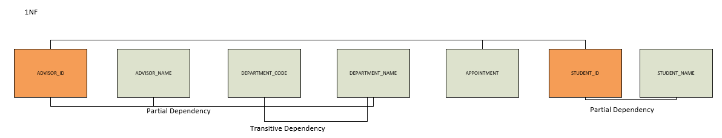
2NF:
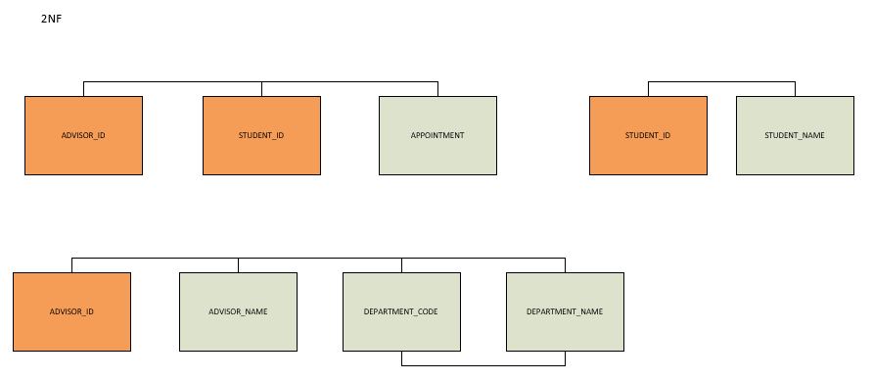
3NF:
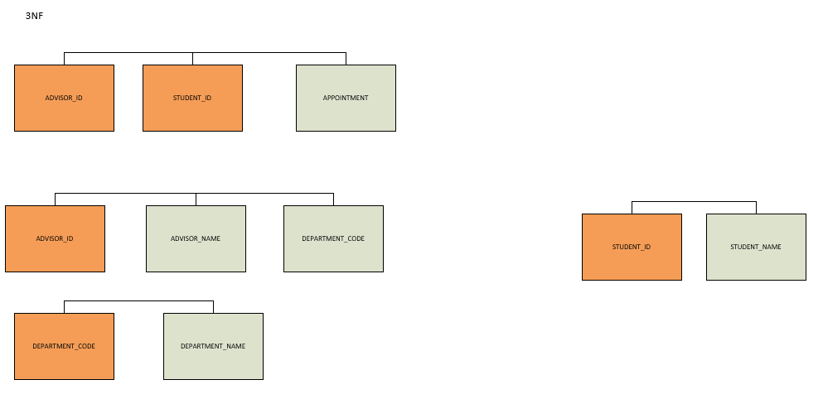

DIAGRAM:
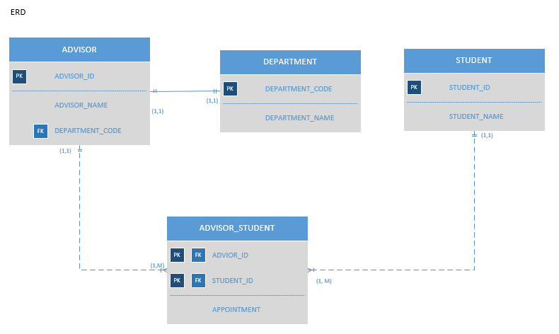
I put the relationship (1:1) between ADVISOR and DEPARTMENT based on the question. In the question there is no evidence that one department can have many advisors. Moreover, there is no clear business rules also stated.

References
Elmasri, R., Navathe, S. B. (2016). Database system concepts and architecture in M. J. Horton, Fundamentals of Database Systems (7th ed) : Pearson.

